HEART RATE ESTIMATOR

ECG signal

Filter

Peak Detector

RR Interval Calculator

Heart Rate Estimator

ECG Signal
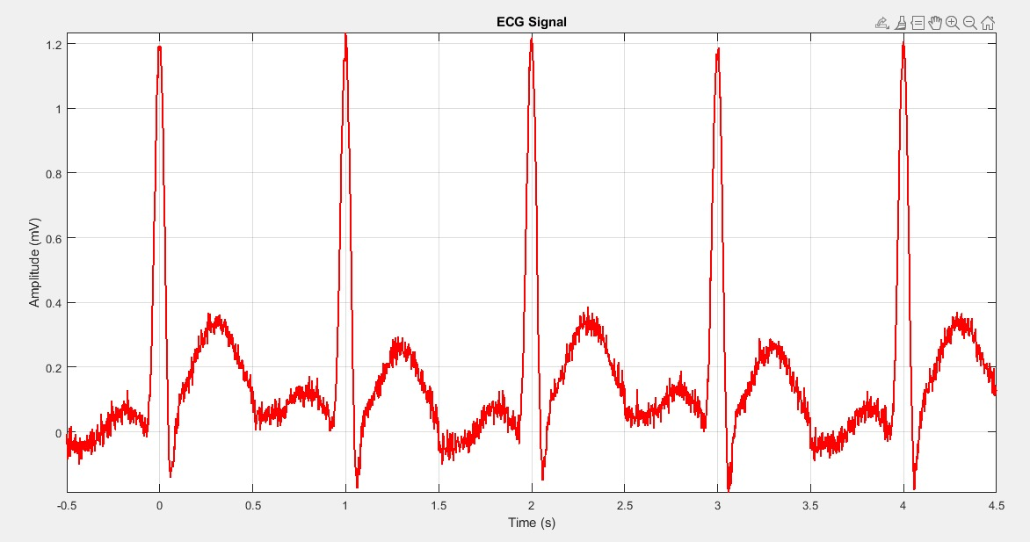
clc;
clear;
close all;

% Sampling frequency
fs = 500; % Standard ECG sampling rate (Hz)
t_total = 5; % Total duration (seconds) for 5 beats
t = 0:1/fs:t_total; % Time vector

% Heart rate (bpm)
HR = 60; % 60 BPM (1 beat per second)
f_HR = HR / 60; % Convert BPM to Hz
ecg_period = 1 / f_HR; % One heartbeat duration

% ECG waveform parameters (P-QRS-T complex)
A_p = 0.1; % P wave amplitude
A_q = -0.15; % Q wave amplitude
A_r = 1.2; % R wave amplitude (main peak)
A_r_neg = -0.5; % Occasional Negative R peak
A_s = -0.4; % S wave amplitude
A_t = 0.3; % T wave amplitude

% Wave timing (based on ECG characteristics)
T_p = -0.2 * ecg_period; % P wave occurs before QRS
T_q = -0.05 * ecg_period; % Q wave slightly before R peak
T_r = 0; % R wave at center
T_r_neg = 0.02 * ecg_period; % Negative R peak (occasional)
T_s = 0.05 * ecg_period; % S wave after R
T_t = 0.3 * ecg_period; % T wave occurs later

% Wave durations (Gaussian standard deviations)
sigma_p = 0.08 * ecg_period; % P wave width
sigma_q = 0.02 * ecg_period; % Q wave width
sigma_r = 0.03 * ecg_period; % R wave width
sigma_r_neg = 0.03 * ecg_period; % Negative R wave width
sigma_s = 0.02 * ecg_period; % S wave width
sigma_t = 0.12 * ecg_period; % T wave width
% Generate ECG for one heartbeat
t_single = -ecg_period/2:1/fs:ecg_period/2;
ecg_heartbeat = zeros(size(t_single));
for i = 1:length(t_single)
ecg_heartbeat(i) = ...
A_p * exp(-((t_single(i) - T_p) .^ 2) / (2 * sigma_p^2)) + ... % P wave
A_q * exp(-((t_single(i) - T_q) .^ 2) / (2 * sigma_q^2)) + ... % Q wave
A_r * exp(-((t_single(i) - T_r) .^ 2) / (2 * sigma_r^2)) + ... % R wave
(mod(i, round(fs * ecg_period * 2)) == 0) * A_r_neg * exp(-((t_single(i) - T_r_neg) .^ 2) / (2 * sigma_r_neg^2)) + ... % Occasional Negative R peak
A_s * exp(-((t_single(i) - T_s) .^ 2) / (2 * sigma_s^2)) + ... % S wave
A_t * exp(-((t_single(i) - T_t) .^ 2) / (2 * sigma_t^2)); % T wave
end
% Generate a full ECG signal with 5 beats
num_beats = 5; % Exactly 5 R-peaks
final_ecg = [];
final_t = [];
for i = 1:num_beats
final_ecg = [final_ecg, ecg_heartbeat]; % Append each heartbeat
final_t = [final_t, t_single + (i-1) * ecg_period]; % Adjust time axis
end
% Add Moderate Noise Components
baseline_wander = 0.05 * sin(2 * pi * 0.5 * final_t); % Mild baseline drift (0.5Hz)
muscle_noise = 0.02 * randn(size(final_t)); % Smaller high-frequency noise
powerline_noise = 0.01 * sin(2 * pi * 50 * final_t); % Weaker 50Hz powerline interference
% Final Noisy ECG Signal
ecg_noisy = final_ecg + baseline_wander + muscle_noise + powerline_noise;
% Save ECG data for further processing
fileID = fopen('ecg_noisy.txt', 'w');
fprintf(fileID, '%f\n', ecg_noisy);
fclose(fileID);
plot(final_t, ecg_noisy, 'r', 'LineWidth', 1.5);
title('ECG Signal');
xlabel('Time (s)');
ylabel('Amplitude (mV)');
grid on;
axis tight;

Filter

ECG Signal

Differentiator Rectifier Integrator

Filtered O/P

Differentiator
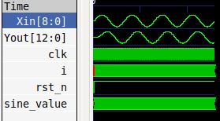

Rectifier
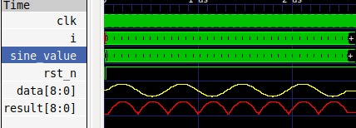

Integrator
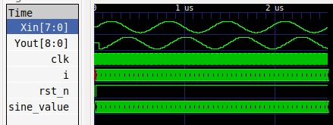

Verilog Code
module heart_rate_pipeline (
input clk,
input rst_n,
input signed [7:0] Xin,
output signed [12:0] Yout
);
// Stage 1: Differentiation (Xin - Xin_prev)
reg signed [7:0] Xin_Reg [1:0];
always @(posedge clk or negedge rst_n) begin
if (!rst_n) begin
Xin_Reg[0] <= 8'd0;
Xin_Reg[1] <= 8'd0;
end else begin
Xin_Reg[1] <= Xin_Reg[0];
Xin_Reg[0] <= Xin;
end
end
wire signed [8:0] diff_out = Xin_Reg[0] - Xin_Reg[1];

// Stage 2: Rectification (Absolute Value)
reg signed [8:0] rect_out;
always @(posedge clk or negedge rst_n) begin
if (!rst_n)
rect_out <= 9'd0;
else
rect_out <= (diff_out[8] == 1'b0) ? diff_out : (~diff_out + 1'b1);
end

// Stage 3: Integration (16-element shift register + 4-level adder tree)
reg signed [8:0] Xin_Reg_Inte [15:0];
integer i; // Declare integer outside the always block
always @(posedge clk or negedge rst_n) begin
if (!rst_n) begin
for (i = 0; i < 16; i = i + 1)
Xin_Reg_Inte[i] <= 9'd0;
end else begin
for (i = 15; i > 0; i = i - 1)
Xin_Reg_Inte[i] <= Xin_Reg_Inte[i - 1];
Xin_Reg_Inte[0] <= rect_out;
end
end

// 4-level adder tree for accumulation
wire signed [12:0] sum_lvl_2;
assign sum_lvl_2 = Xin_Reg_Inte[0] + Xin_Reg_Inte[1] + Xin_Reg_Inte[2] + Xin_Reg_Inte[3] +
Xin_Reg_Inte[4] + Xin_Reg_Inte[5] + Xin_Reg_Inte[6] + Xin_Reg_Inte[7] +
Xin_Reg_Inte[8] + Xin_Reg_Inte[9] + Xin_Reg_Inte[10] + Xin_Reg_Inte[11] +
Xin_Reg_Inte[12] + Xin_Reg_Inte[13] + Xin_Reg_Inte[14] + Xin_Reg_Inte[15];
assign Yout = sum_lvl_2;
endmodule

Testbench for Filter :
`timescale 1ns/1ps
module heart_rate_pipeline_tb;
// Inputs
reg clk;
reg rst_n;
reg signed [7:0] Xin;
// Outputs
wire signed [12:0] Yout;
// Instantiate the Unit Under Test (UUT)
heart_rate_pipeline uut (
.clk(clk),
.rst_n(rst_n),
.Xin(Xin),
.Yout(Yout)
);

initial begin
clk = 0;
forever #5 clk = ~clk; // 10ns period clock
end
initial begin
rst_n = 0;
#20; // Hold reset for 20ns
rst_n = 1;
end
// Read ECG data from file and apply to Xin
integer file;
integer scan_result;
real ecg_value;
initial begin
file = $fopen("ecg_signal.txt", "r");
if (file == 0) begin
$display("Error: Could not open file.");
$finish;
end
// Initialize Xin
Xin = 0;
#30;
while (!$feof(file)) begin
scan_result = $fscanf(file, "%f\n", ecg_value); // Read a floating-point value from the file
if (scan_result != 1) begin
$display("Error: Failed to read ECG value from file.");
$finish;
end
Xin = $rtoi(ecg_value *127); // Convert to 8-bit fixed-point
#10;
end
//Close the file
$fclose(file);

// Finish the simulation
#100;
$finish;
end

// Monitor the outputs
initial begin
$monitor("Time: %0t | Xin: %d | Yout: %d", $time, Xin, Yout);
$dumpfile("heart_rate_pipeline");
$dumpvars(0, heart_rate_pipeline_tb);
end

endmodule

Filtered Output :

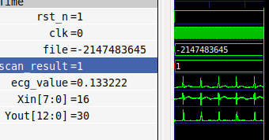

Peak Detector

Features

Threshold Fixed RR interval
Adjustment for to avoid Fault
Peak detection Detection

Code :
module self_adaptive_threshold (
input clk,
input rst_n,
input signed [12:0] transformed_signal,
output reg peak_detected);
reg signed [12:0] signal_buffer [0:255];
reg [7:0] index;
integer j;
always @(posedge clk or negedge rst_n) begin
if (!rst_n)
index <= 8'd0;
else if (index < 8'd255)
index <= index + 8'd1;
else
index <= 8'd0;
end
always @(posedge clk or negedge rst_n) begin
if (!rst_n) begin
for (j = 0; j < 256; j = j + 1)
signal_buffer[j] <= 13'd0;
end else
signal_buffer[index] <= transformed_signal;
end

// Calculate the maximum value in the buffer
reg signed [12:0] max_value, temp_max_value;
always @(posedge clk or negedge rst_n) begin
if (!rst_n)
max_value <= 13'd0;
else begin
temp_max_value = 13'd0;
for (j = 0; j < 256; j = j + 1)
if (signal_buffer[j] > temp_max_value)
temp_max_value = signal_buffer[j];
max_value <= temp_max_value;
end
end
// Set the dynamic threshold
reg signed [12:0] threshold;
always @(posedge clk or negedge rst_n) begin
if (!rst_n)
threshold <= 13'd0;
else
threshold <= (max_value >> 1) + 13'd50; // Use arithmetic right shift
end
// Detect peaks
always @(posedge clk or negedge rst_n) begin
if (!rst_n)
peak_detected <= 1'b0;
else
peak_detected <= (transformed_signal > threshold);
end
endmodule

Testbench :

`timescale 1ns/1ps

module self_adaptive_threshold_tb;

// Inputs
reg clk;
reg rst_n;
reg signed [7:0] Xin;

// Outputs
wire signed [12:0] Yout; // Output of heart_rate_pipeline
wire peak_detected; // Output of self_adaptive_threshold
heart_rate_pipeline uut_pipeline (
.clk(clk),
.rst_n(rst_n),
.Xin(Xin),
.Yout(Yout)
);

self_adaptive_threshold uut_threshold (
.clk(clk),
.rst_n(rst_n),
.transformed_signal(Yout), // Connect Yout to transformed_signal
.peak_detected(peak_detected)
);

initial begin
clk = 0;
forever #5 clk = ~clk; // 10ns period clock
end

initial begin
rst_n = 0;
#20; // Hold reset for 20ns
rst_n = 1;
end

integer file;
integer scan_result;
real ecg_value;

initial begin
file = $fopen("ecg_signal.txt", "r");
if (file == 0) begin
$display("Error: Could not open file.");
$finish;
end
Xin = 0;
#30;
while (!$feof(file)) begin
scan_result = $fscanf(file, "%f\n", ecg_value); // Read a floating-point value from the file
if (scan_result != 1) begin
$display("Error: Failed to read ECG value from file.");
$finish;
end
Xin = $rtoi(ecg_value * 128);
#10;
end
$fclose(file);

Output :

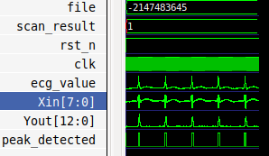

RR Interval Calculator :

Average of N intervals is considered as the RR interval of the ECG to enhance accuracy

Code :
module RR_Interval_Calculator (
input clk,
input rst_n,
input peak_detected,
output reg [15:0] avg_interval
);
parameter NUM_PEAKS = 4;
reg output_valid;
reg [15:0] current_time;
reg [15:0] sum_intervals;
reg [3:0] index;
reg [15:0] current_interval;
reg [15:0] prev_time;
reg calibration_done;
reg prev_peak_detected;
wire peak_rising_edge;
assign peak_rising_edge = peak_detected && !prev_peak_detected;
integer i;
always @(posedge clk or negedge rst_n) begin
if (!rst_n) begin
prev_time = 16'd0;
current_time = 16'd0;
index = 4'd0;
sum_intervals = 16'd0;
avg_interval = 16'd0;
calibration_done = 1'b0;
output_valid = 1'b0;
prev_peak_detected = 1'b0;
end
else begin
prev_peak_detected = peak_detected;
if (peak_rising_edge) begin
if (prev_time == 16'd0) begin
prev_time = current_time;
end
else begin
current_interval = current_time - prev_time;
sum_intervals = sum_intervals + (current_time - prev_time);
prev_time = current_time;
if (!calibration_done) begin
if (index == NUM_PEAKS-1) begin
avg_interval = sum_intervals / (NUM_PEAKS);
calibration_done = 1'b1;
output_valid = 1'b1;
end else begin
index = index + 1;
end
end
end
end
else begin
current_time = current_time + 1;
end
end
end
endmodule

Testbench :

`timescale 1ns/1ps
module RR_interval_calculator_tb;
reg clk;
reg rst_n;
reg signed [7:0] Xin;
wire signed [12:0] Yout;
wire peak_detected;
wire [15:0] avg_RR_interval;
heart_rate_pipeline uut_pipeline (
.clk(clk),
.rst_n(rst_n),
.Xin(Xin),
.Yout(Yout)
);
self_adaptive_threshold uut_threshold (
.clk(clk),
.rst_n(rst_n),
.transformed_signal(Yout),
.peak_detected(peak_detected)
);
RR_Interval_Calculator uut_rr_calculator (
.clk(clk),
.rst_n(rst_n),
.peak_detected(peak_detected),
.avg_interval(avg_RR_interval)
);
initial begin
clk = 0;
end
always #10 clk = ~clk;
initial begin
rst_n = 0;
#20;
rst_n = 1;
end

integer file;
integer scan_result;
real ecg_value;
initial begin
file = $fopen("ecg_signal.txt", "r");
if (file == 0) begin
$display("Error: Could not open file.");
$finish;
end

Xin = 0;
#30;
while (!$feof(file)) begin
scan_result = $fscanf(file, "%f\n", ecg_value);
if (scan_result != 1) begin
$display("Error: Failed to read ECG value from file.");
$finish;
end
Xin = $rtoi(ecg_value * 128);
#10;
end
$fclose(file);
#100;
$finish;
end
initial begin
$monitor("Time: %0t | Xin: %d | Yout: %d | Peak Detected: %b | Avg RR Interval: %d",
$time, Xin, Yout, peak_detected, avg_RR_interval);
$dumpfile("RR_interval_calculator.vcd");
$dumpvars(0, RR_interval_calculator_tb);
end
endmodule

Output :

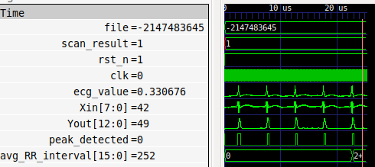

Top Level Module :

module hr_estimator_top(
input clk, rst_n,
input signed [7:0] Xin,
output wire [15:0] avg_interval // Change reg to wire here
);
wire signed [12:0] Yout;
wire peak_detected;
// Instantiate the heart_rate_pipeline module
heart_rate_pipeline filter_inst(
.clk(clk),
.rst_n(rst_n),
.Xin(Xin),
.Yout(Yout)
);
// Instantiate the self_adaptive_threshold module
self_adaptive_threshold peak_detector_inst(
.clk(clk),
.rst_n(rst_n),
.transformed_signal(Yout),
.peak_detected(peak_detected)
);
// Instantiate the RR_Interval_Calculator module
RR_Interval_Calculator #(.NUM_PEAKS(4)) RR_inst(
.clk(clk),
.rst_n(rst_n),
.peak_detected(peak_detected),
.avg_interval(avg_interval) // avg_interval is driven by this module, so it's a wire
);
endmodule

Testbench :
module hr_estimator_tb();
reg clk;
reg rst_n;
reg signed [7:0] Xin;
wire [15:0] avg_interval;
hr_estimator_top DUT(.clk(clk), .rst_n(rst_n), .Xin(Xin), .avg_interval(avg_interval));
initial begin
clk = 0;
end
always #10 clk = ~clk;
initial begin
rst_n = 0;
#20;
rst_n = 1;
end
integer file;
integer scan_result;
real ecg_value;
initial begin
file = $fopen("ecg_signal.txt", "r");
if (file == 0) begin
$display("Error: Could not open file.");
$finish;
end
Xin = 0;
#30;
while (!$feof(file)) begin
scan_result = $fscanf(file, "%f\n", ecg_value);
if (scan_result != 1) begin
$display("Error: Failed to read ECG value from file.");
$finish;
end
Xin = $rtoi(ecg_value * 128);
#10;
end
$fclose(file);
#100;
$finish;
end
initial begin
$monitor("Time: %0t | Xin: %d | Avg RR Interval: %d", $time, Xin, avg_interval);
end
endmodule

Schematic Diagram :

